Project Design Phase
Problem -solution Fit Template

Date | 1 November 2025
Team ID | NM2025TMID02455
Project Name | Medical Inventory Management
Maximum Mark | 2Marks

Problem-Solution Fit Template:
Hospitals and medical facilities often face challenges in tracking and maintaining essential medical inventory, which leads to issues such as stock shortages, overstocking, expired medicines, and delays in patient care. Manual record-keeping is prone to human error and lacks real-time visibility, making it difficult for staff to monitor inventory levels efficiently. To solve this, the Medical Inventory Management System provides an automated platform to track stock availability, send low-stock and expiry alerts, manage supplier details, and generate reports for better decision-making. By optimizing inventory workflows, this solution ensures timely availability of supplies, reduces wastage, improves operational efficiency, and enhances overall healthcare quality.
Purpose:
• To automate the tracking and management of medical inventory.
• To ensure timely availability of medicines and medical supplies.
• To prevent stock shortages, overstocking, and expiry-related wastage.
• To provide real-time updates and alerts for low-stock and expiry items.
• To improve accuracy and reduce human errors in inventory handling.
• To support better decision-making with detailed reports and analytics.
• To enhance operational efficiency and improve patient care quality.

Template:
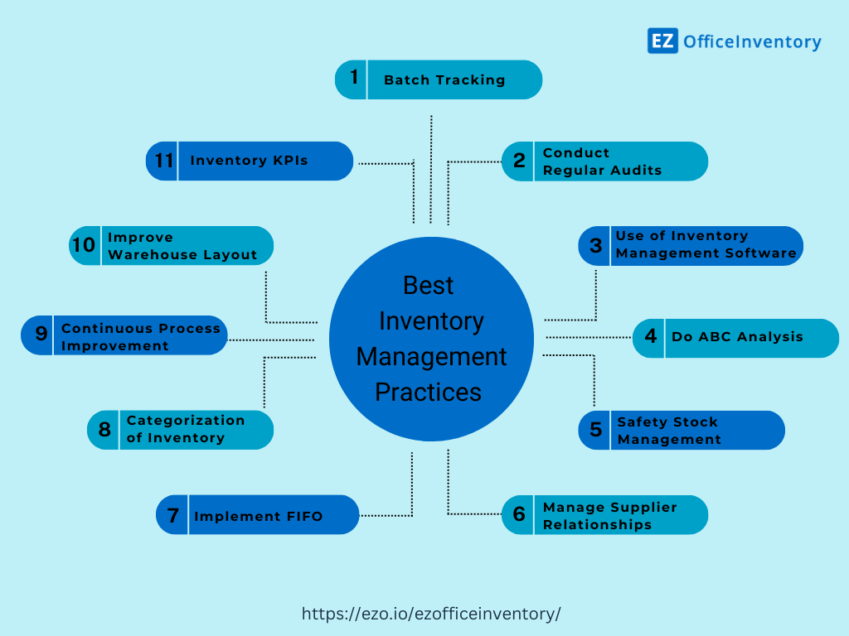

Reference:
- https://chatgpt.com/c/6906268f-47c0-8321-9c19-1aaab457215a

For inventory management, a representative image often features organized storage shelves, barcodes, workers using digital devices to scan or monitor stock, and dashboards displaying inventory data. This typically conveys concepts like tracking, control, and efficient warehouse operations crucial to effective inventory management

